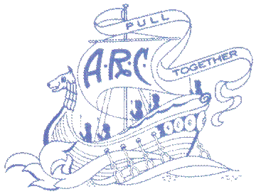

ARGONAUT ROWING CLUB
ACTIVITY WAIVER

Please print the following information:

Name: _________________________________________________________________

Address:________________________________________________________________

Phone: ______________________________ Email:______________________________
Activity:
Date: ___________________________________________________________________

Terms and conditions:
- I agree to hold harmless and release the Argonaut Rowing Club (“ARC”) from any injury, damage or loss HOWEVER CAUSED sustained by myself.
- I agree to conduct myself in a manner consistent with the rules of conduct of the ARC and the applicable laws of the jurisdiction in which I am.
- I agree to abide by the Club Code of Conduct, all rules, the By-laws and Policies of the ARC including the safety rules and guidelines of the ARC and of the Canadian Coast Guard. I agree that a violation of the safety rules and guidelines may result in the suspension or termination of my membership and privileges with the Argonaut Rowing Club.
- I agree and acknowledge that I undertake any activity, including rowing, weight and fitness training entirely at my own risk, and that I am medically fit to undertake such activity.
- I agree that the ARC is not responsible for any personal injury sustained by myself or any other person, or for the loss or damage to any property which I have brought to the premises including but not limited to single or double shells, whether caused by theft, during transportation or by any other cause, including negligence of the ARC or any of its members, coaches, servants, agents or contractors.
- I agree to hold the ARC harmless for any personal injury sustained by myself or any other person while I am being transported in the ARC’s truck, in a car or bus rented by the ARC for the purpose of traveling to and or from any Regatta or other event, either in Canada or in the United States of America.

I have read all of the above terms and conditions, and I understand them and agree to abide by them.

Signature:___________________________________________ Date___________________________
Age: (if under 18 ______________. If you are under 18 years of age, this application must be co-signed by a parent or legal guardian.

Guardian’s name (please print): _________________________________________________________

Signature:___________________________________________ Date___________________________

